We’ve seen how to connect our java servers to our database with JDBC. That’s cool, but it’s only 2/3rds of a traditional full stack application. We need to learn how to send data back and forth between a front end and back end. We'll learn how to attach a webpage to our Java servers in the following weeks, but for now, we’ll use Postman as a sort of mock front end.
Full stack applications are: front end -> back end -> database

What is the internet?

- “A global computer network providing various information and communication services, connected through standardized communication protocols.”
  - Basically, the internet is a bunch of computers/applications messaging each other.
- The internet is made up of computers sending messages to other computers. These messages typically contain data, or requests for data.
  - Our full-stack apps will involve having a webpage communicate to our Java servers over HTTP. The webpage will send requests to the server, which returns a response.

Client-Server Architecture

- A client-server architecture is a networking model in which the server provides services to clients to perform user-based tasks.
- A client and a server are simply two pieces of software. They could be on the same computer, or they could be on two different computers across the globe.
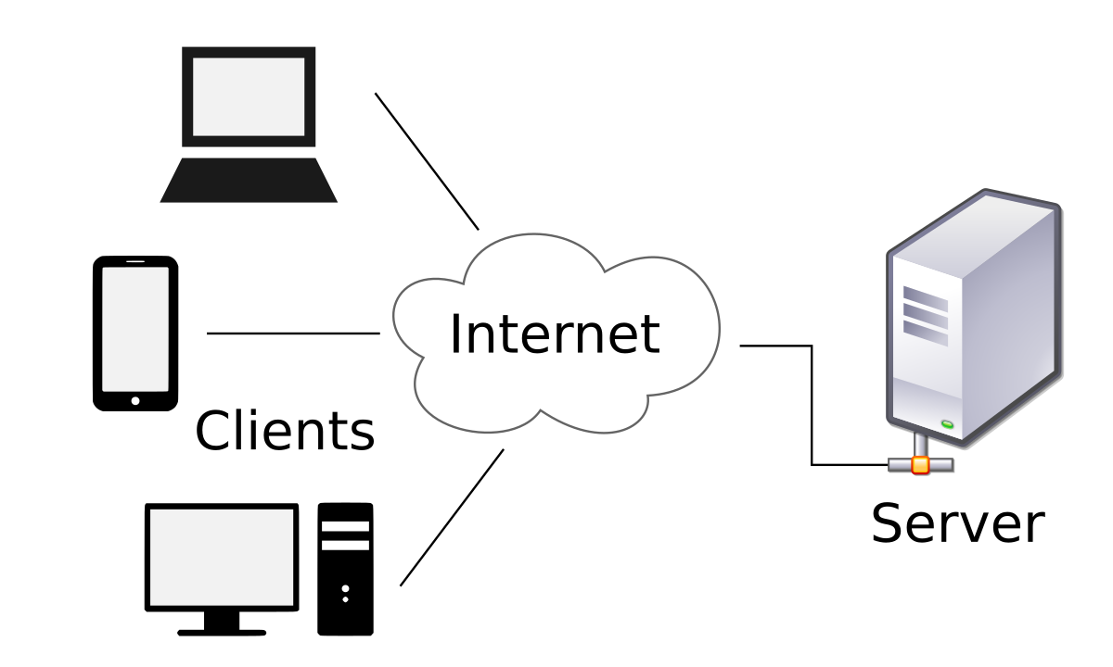
- The Client is usually a browser/web page/frontend. It sends requests to a server.
- The Server is usually a backend server/logic like Java which accesses a database like Postgres.
  - The server processes a response and sends it back to the client.

- 3-Tiered Client-Server Architectures
  - These are the types of applications we’ll be creating. Each tier has a name:
    - Presentation tier (front end - HTML/CSS/JS/TS/Angular)
    - Application tier (backend- server/middleware - Java)
    - Data tier (Database -> PostgreSQL)

HTTP

- HyperText Transfer Protocol - The standard protocol for sending and receiving information over the internet as well as in our full-stack applications.
  - This is the most commonly used protocol for sending information between a client and server. (front end <-> back end)

- HTTP achieves communication through HTTP requests and HTTP responses:

  - An HTTP Request is made up of these parts:
    - Method/Verb - This indicates the intended type of action for the request
      - (GET to receive data, POST to send data, etc. see below)
    - URL - Location the request is going to.
    - Header - contains metadata about the request (we’ll see some later)
    - Body - Contains the information being sent to the server (if any)
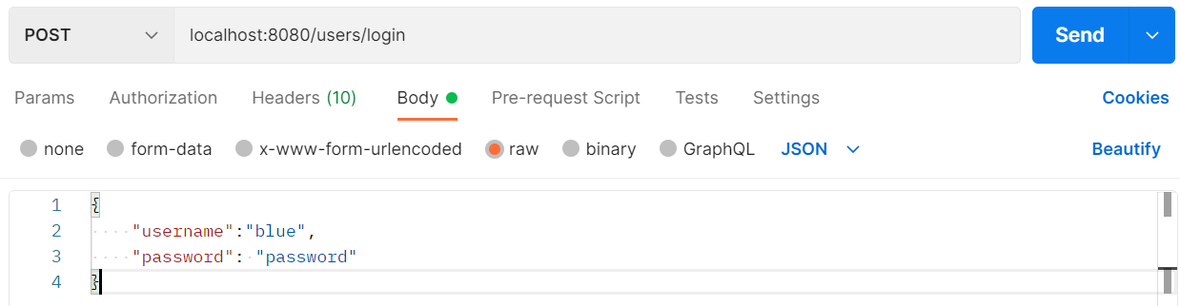

1)
2)
3)
4)

  - An HTTP Response has 3 parts:
    - Status code - tells if the request was successful or not, and some information about why. (read below)
    - Header - metadata
    - Body – information returned from response. (if any)
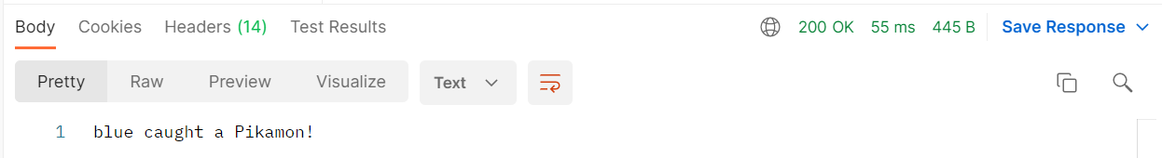

1)
3)
2)

- What is an HTTP verb? This is how we communicate to the server what our request is meant to do. Note the parallels to the CRUD operations.
    - GET - This is simply used to request information. Generally, it will have an empty body.
      - Analogous to a select statement in SQL.
    - POST - This is used to create a new object/add completely new information to the database. This information should be contained in the request body.
      - Analogous to insert statements in SQL.
        - Not always – SELECT is behind Login requests for example
    - PUT - Used to update a complete resource. Information should be in the body.
      - Analogous to update statements in SQL.
      - PUT will update every column the row has.
    - PATCH - Used to update a specific part of a resource. Updating a single field for an object, not the entire object.r
      - Analogous to update table set column1, column2, column(n).
      - PATCH will update only specific columns
    - DELETE - Removes the resource.
      - Analogous to delete statements in SQL.
    - HEAD - just returns the header of the request.
      - Remember, the header has stuff like cookies and other metadata

  - Safe vs Idempotent Verbs:
    - Safe - the verb will not make any changes to the server or the database.
      - GET, HEAD
    - Idempotent - Sending this request once may or may not change the state of the database. However, if I repeat the same request, the server/database will stay the same. It should also return the same result.
      - GET, DELETE, PUT, HEAD
    - Notice that POST is neither safe nor idempotent - a successful POST request will always change the database (adds data to the DB).
      - PATCH is not always idempotent, depends on the state of the resource

Status Codes

- The part of an HTTP response that indicates the result of the request. There are 5 levels of status codes each with multiple specific codes.

  - 100: Informational (not often used - relays some information)
    - 101: Switching protocols
  - 200: Success (The request was successfully handled)
    - 200 - OK (default for successful responses)
    - 201 - Created
    - 202 - Accepted
    - 204 - No Content
  - 300: Redirects (If the request got sent elsewhere by the server)
    - 300 - Multiple Choices
    - 302 - Found
    - 301 - Moved Permanently
    - 307 - Temporary Redirect
  - 400: Client-Side errors (Something went wrong on the front end)
    - 400 - Bad Request
    - 401 - Unauthorized
    - 403 - Forbidden
    - 404 - Not Found
    - 418 - I’m a teapot (not a coffee maker) - the request is trying to do something the application is not designed to do.
    - 420 - Enhance your calm - too many requests received within a short time.
  - 500: Server-side errors (Something went wrong on the backend)
    - 500 - Internal server error.
    - 501 - Not Implemented
    - 502 - Bad gateway.
    - 504 - Gateway timeout.
  - https://http.cat/ Visuals to go along with status codes.

JavaScript Object Notation (JSON)

- JSON is a syntax for storing and exchanging information/data between our frontend and backend. At its core, it’s just text, but it’s formatted in a way to make it easy to use in your code.
  - We’re going to be using JSON ALL THE TIME to send data between our front end and back end. This is its main purpose for us.
  - We are going to be sending/receiving JSON in the bodies of our HTTP requests and responses.
- JSON has JavaScript in the name, because it uses JavaScript object syntax, but JSON is not specific to JS. In other words, it's language agnostic.

- Data is stored in an object composed of comma delimited key/value pairs (like a JS object), but the key must be a String. Here’s a hypothetical JSON object:

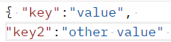
}

- JSON object values may be of any of the following types:
  - String
  - Number
  - Array
  - Boolean
  - Other JSON objects
  - Null
  - (NOTE: you cannot have a function, date, or undefined)

- PROBLEM: Java cannot read JSON. When we get JSON in the backend, we need to translate it to Java. Conversely, when we’re sending data back, we need to convert from Java to JSON.
  - JSON is like a universal translator. But we have to translate it from JSON to whatever language we’re using. This is how apps written in Java can communicate with apps written in JavaScript, Python, etc.
- In Java, we'll use a Library in Javalin to process HTTP Requests and make JSON <-> Java conversions.

What is Postman?

- Postman is a service that lets us make HTTP requests to a server. You can see what it looks like in the pictures above.
  - We’ll be using it to test our java servers (to make sure the appropriate data and status codes get returned)
  - It will be VERY helpful for us because we can test whether our Java servers work before building up a front end.
    - Something goes wrong making a request from the front end? Pop that same request into postman. If it works, the problem is likely on the front end. If it fails, the problem is likely on the backend.
  - When I’m making a full stack app, I typically make the server first, and test every functionality in postman before building the front end.

BIG PICTURE: We use Javalin to receive HTTP requests from postman or a webpage. The HTTP requests sent to the backend get handled by Javalin Handlers. If there is JSON data in the request, it will be translated by Javalin. Any HTTP responses sent back by these Javalin Handlers will typically contain JSON data that has been converted from Java objects.

